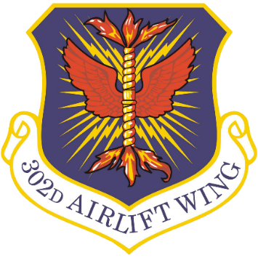
302nd Airlift Wing
Fact Sheet

The Air Force Reserve 302nd Airlift Wing is located at Peterson Space Force Base in Colorado Springs, Colorado. The 302nd AW trains, equips and employs C-130H aircraft airlift forces in worldwide support of the nation's vital interests, with a Total Force of more than 1,400 personnel.
The wing is assigned eight C-130 Hercules aircraft, which are flown by the wing's 731st Airlift Squadron.
MISSION: The mission of the 302nd AW is to train, equip and employ airlift forces in worldwide support of the nation's vital interests. The primary operational missions of the 302nd AW are tactical airlift and airdrop, and aeromedical evacuation. The wing also conducts the special mission of aerial firefighting employing the U.S. Forest Service's Modular Airborne Fire Fighting Systems (MAFFS).
Units assigned to the 302nd AW can be activated and deployed from the United States to any world-wide location.
ORGANIZATION: The 302nd AW comes under the operational control of the Air Force Reserve Command, headquartered at Robins AFB, Georgia, through its numbered Air Force, 22nd Air Force, based at Dobbins Air Reserve Base, Georgia, When called to active duty through presidential order, the wing would become an active duty unit under the command of Air Mobility Command, based at Scott AFB, Illinois.
There are three groups and a medical squadron assigned to the 302nd AW. These include:
- 302nd Operations Group: 34th Aeromedical Evacuation Squadron, 302nd Operations Support Squadron and 731st Airlift Squadron
- 302nd Maintenance Group: 302nd Maintenance Squadron and 302nd Aircraft Maintenance Squadron
- 302nd Mission Support Group: 39th Aerial Port Squadron, 302nd Civil Engineer Squadron, 302nd Communication Flight, 302nd Force Support Squadron, 302nd Logistics Readiness Squadron and 302nd Security Forces Squadron
ECONOMIC IMPACT: In Fiscal Year 2024 the value of 302nd AW jobs created, annual payroll and construction services and procurements totaled $76 million dollars.
HISTORY: Established as the 302nd Troop Carrier Wing on May 16, 1949, the 302nd AW was first activated by the Air Force Reserve on June 27, 1949. In the mid-1950s, the wing flew airlift operations in the United States and overseas.
The 302nd AW was called to active duty during the Cuban missile crisis of 1962. During the 1960s, wing aircraft and crews performed worldwide airlift missions and participated in numerous tactical exercises. The unit was deactivated on April 1, 1981. In mid-1983, the unit, then designated the 901st Tactical Airlift Group, moved to its newly constructed facilities at Peterson SFB and was reactivated as the 302nd Airlift Wing on April 1, 1985.
SPECIAL MISSION (MAFFS): The 302nd AW is the only Air Force Reserve wing trained and equipped for the Modular Airborne Fire Fighting System (MAFFS) mission, which involves air dropping fire retardant to aid in the suppression of wildland fires. The U.S. Department of Agriculture Forest Service-owned MAFFS systems can be loaded and installed on a C-130 Hercules aircraft within hours. The wing has flown firefighting missions throughout the Western United States since the 302nd AW took on the Reserve portion of the MAFFS mission in 1993.
The MAFFS-equipped C-130s are operated by four military airlift wings: The 146th Airlift Wing, California Air National Guard; 152nd Airlift Wing, Nevada Air National Guard; the 153rd Airlift Wing, Wyoming Air National Guard; and the 302nd Airlift Wing, U.S. Air Force Reserve Command.
MAFFS is a mission that highlights interagency cooperation. The 302nd AW is a federal force belonging to the Department of War and works in concert with the National Interagency Fire Center, and the US Forest Service. NIFC determines firefighting needs and strategies. When it is determined MAFFS will be utilized, NIFC through U.S. Northern Command, requests the MAFFS assets.

